UNIVERSITY MARKETING PLAN

[YOUR COMPANY NAME]

Date:

Index

Executive Summary | [page Number]
Company Overview | [page Number]
Products and Services | [page Number]
Marketing Analysis | [page Number]
Strategy and Implementation | [page Number]
Management and Personnel | [page Number]
Financial Plan | [page Number]

EXECUTIVE SUMMARY

[[UNIVERSITY NAME]]. It offers classroom and online business degree courses to students between ages [18-22]. The university sees a growing demand for business courses in the next [two years] as more individuals enroll in colleges/universities that specialize in business-related courses or programs.

[UNIVERSITY NAME] for Business has yet to establish its brand in [LOCATION]. The university plans to effectively market its course offerings on its website. It will also utilize social media and plans to post video content as a marketing strategy. The university expects to gain a [15%] increase in the number of enrollees.

COMPANY OVERVIEW

Mission Statement: [[UNIVERSITY NAME]] for Business provides an excellent quality of education that prepares each student to become a well-rounded citizen and a productive professional in his/her chosen business career.

Philosophy: [[UNIVERSITY NAME]] for Business empowers its educators to provide wisdom and instill academic leadership to students, making them contributing assets of the community someday.

Vision: [[UNIVERSITY NAME]] for Business is one of the recognized [LOCATION]

Outlook: There is a great demand for higher academic institutions to offer effective business-related courses and management programs. Today, more individuals have become more interested to take on such programs because they know it will lead them to landing good corporate jobs. The university aims to take advantage of this demand and seeks to gain increments in the number of enrollees in the next two years.

Type of Industry: Educational Services Industry

Business Structure: Corporation

Ownership: Corporation,

Start-Up Summary: [[UNIVERSITY NAME]] for Business initially operated with a capital of [₹100,000] generated by the owner through equity financing. The funds covered payment for disbursements such as insurance, legal fees, payroll, advertising, and rent.

Start-Up Funding
Start-Up Expenses | ₹56,250
Start-Up Assets | ₹43,750
Total Funding Required | ₹100,000
Assets
Non-Cash Assets from Start-Up | ₹28,500
Cash Requirements from Start-up | ₹2,000
Additional Cash Raised | ₹12,750
Cash Balance on Starting Date | ₹500
Total Assets | ₹43,750
Capital
Planned Investment
Owner | ₹100,000
Other | ₹0
Additional Investment Requirement | ₹0
Total Planned Investment | ₹100,000
Loss at Start-Up (Start-Up Expenses) | -₹56,250
Total Capital | ₹43,750
Total Capital and Liabilities | ₹43,750
Start-Up
Requirements
Start-Up Expenses
Rent - 5 Months | ₹7,500
Advertising | ₹3,750
Legal Fees | ₹2,500
Staff Training | ₹3,250
Insurance | ₹4,250
Other | ₹35,000
Total Start-Up Expenses | ₹56,250
Start-Up Assets
Cash Required | ₹2,500
Start-Up Inventory | ₹8,500
Other Current Assets | ₹12,750
Long-Term Assets | ₹20,000
Total Assets | ₹43,750
Total Requirements (Total Start-Up Expenses + Total Assets) | ₹100,000

PRODUCTS AND SERVICES

Product/Service Description: [UNIVERSITY NAME] for Business offers the following business courses:
Accounting and Financial Management
Business Administration
Marketing
Human Resource Management
Economics

Value Proposition: [[UNIVERSITY NAME]] for Business shows consistency in providing its students with the quality education that they deserve.

Pricing Strategy: [[UNIVERSITY NAME]] for Business uses a combination of the credit-hour pricing and program differential tuition pricing strategies. The university charges students different credit-hour rates depending on the business course they enrolled in.

MARKETING ANALYSIS

Technological advancement has drastically changed the educational services industry over the years. There are more opportunities now for underprivileged individuals to take business courses they vie for with the availability of online classes among prestigious universities. Universities project increasing market demand as more students enroll in colleges and universities to develop the necessary skills for employment.

Market Segmentation

[[UNIVERSITY NAME]] for Business will focus its marketing strategies in attracting students between ages [18-22] to enroll in either classroom or online business courses of the university. The chart below shows that the university’s target market makes up a large percentage of enrollees among colleges and universities in Dallas, [LOCATION].

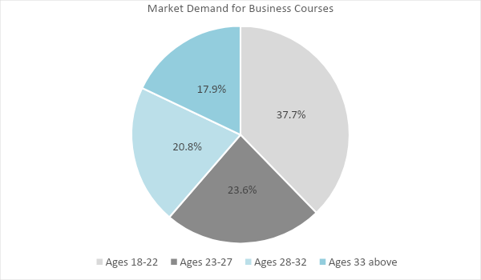
Target Market Segmentation Strategy

Students ages [18-22]
Use the university’s website to promote its programs to this group
Use video marketing to promote the university on various social media platforms

Students from other age groups

Promote the university’s brand and reputation by communicating a strong message that attracts the attention of these age groups (e.g. scholarship and exchange programs, extracurricular activities of their interests, etc.)

STRATEGY AND IMPLEMENTATION

Target Market Strategy

[[UNIVERSITY NAME]] for Business aims to increase the number of enrollees by [15%] in the next academic year with the strategic implementation of its marketing strategies.

Competitive Edge

SWOT Analysis | Strengths | Weaknesses | Opportunities | Threats
[UNIVERSITY NAME] | University location is within a populous metropolitan | Lack of relevant online content to promote the university’s programs | A growing interest in business courses among young adults for employment purposes | The existence of online classes from established and influential universities
[COMPETITION NAME] | Recognized as one of the top universities in [LOCATION] | Does not offer online business courses | A partnership with other academic institutions in other [LOCATIONS] | Strict requirements in other [LOCATION] that may jeopardize partnerships
[COMPETITION NAME] | Trusted provider of online business courses | Understaffed at various levels and courses | The opening of online opportunities worldwide | Stagnant state investment in online programs

Sales Strategy and Forecast

With an optimized website and a heightened marketing content, [[UNIVERSITY NAME]] for Business projects the following monthly sales in USD:

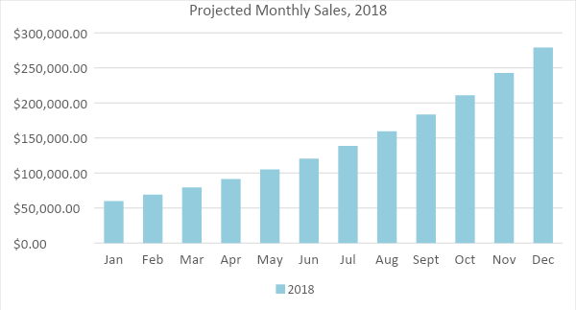
The following chart shows the anticipated percentage growth in the number of enrollees in the next two years following the implementation of its marketing strategies.

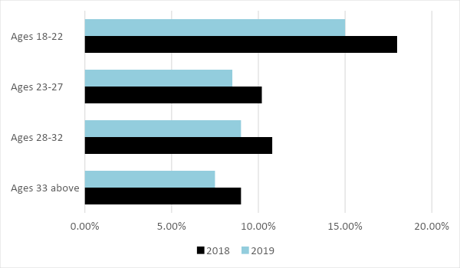

Marketing Strategy

[[UNIVERSITY NAME]] for Business will optimize its website and use videos as its marketing content on various social media channels. The university will start the implementation of these strategies once the following milestones have been achieved.

Milestones

Marketing Strategy | Activities | Timeline | Success Criteria
Search Engine Optimization (SEO) | Hire the services of an SEO company to optimize the university website for better search engine results ranking. | ASAP | Target market easily finds the university’s website when they search for business courses they want to enroll in.
Video Marketing | Gather and compile in an informative video the positive attributes of the university | January 5, 2018 | The university posted video content on its social media pages like Facebook and Instagram starting January 31, 2018.

MANAGEMENT AND PERSONNEL

[[UNIVERSITY NAME]] for Business is headed by the university president, [Dr. Violet Bruno], who is guided by the board of trustees. Executive management includes the vice president of academic and student affairs as well as the finance and human resource directors. The university employs [300] educators.

FINANCIAL PLAN

[UNIVERSITY NAME] for Business projects the following break-even, profit and loss, balance sheet, and cash flow figures in the next two years.

Break-Even Analysis

Fixed Costs | Average Price | Variable Costs | Contribution Margin | Break-Even Units
₹2,350.00 | ₹24.50 | ₹12 | ₹12 | 191
Fixed Costs | Amount |  | Variable Costs | Per Unit Amount
Rent | 1,500 |  | Advertising | 3.33
Insurance | 850 |  | Legal Fees | 5.00
 |  |  | Staff Training | 3.85
Total | 2,350 |  | Total | ₹12

Fixed Costs
Business Lease - Rent |  | ₹1,500
Insurance |  | ₹850
Total Fixed Costs |  | ₹2,350
Total Units Sold in 1 Month |  | 2,500
Variable Costs (Unit Sold/Cost per Unit)
Advertising | ₹750 | ₹3.33
Legal Fees | ₹500 | ₹5.00
Staff Training | ₹650 | ₹3.85
Total Variable Cost (Per Unit) |  | ₹12
Break-Even
Selling Price Per Unit |  | ₹24.50
Break-Even Point Per Unit [Fixed Costs/(Sales Price Per Unit - Variable Cost Per Unit)] |  | ₹2,350
 |  | ₹12
Break-Even Point in Units |  | 191
Contribution Margin (Selling Price - Total Variable Cost) |  | ₹12

Profit and Loss Projection
 | FY2018 | FY2019 | FY2020
Sales | ₹300,000.00 | ₹390,000.00 | ₹507,000.00
Direct Cost of Sale | ₹126,000.00 | ₹156,000.00 | ₹202,800.00
Other Cost of Sale | ₹5,000.00 | ₹6,250.00 | ₹7,812.50
Total Cost of Goods Sold or COGS (Sales - Direct Cost of Sale - Other Cost of Sale) | ₹169,000.00 | ₹227,750.00 | ₹296,387.50
Gross Profit (Sales-Total Cost of Goods Sold) | ₹131,000.00 | ₹162,250.00 | ₹210,612.50
Gross Margin % (Gross Profit/Sales) | 43.67% | 41.60% | 41.54%
Operating Expenses
Rent | ₹18,000.00 | ₹18,000.00 | ₹18,000.00
Insurance | ₹10,200.00 | ₹10,200.00 | ₹10,200.00
Utilities | ₹5,000.00 | ₹5,000.00 | ₹5,000.00
Salary (Including Tax) | ₹25,000.00 | ₹25,000.00 | ₹25,000.00
Maintenance & Supplies | ₹5,000.00 | ₹5,000.00 | ₹5,000.00
Total Operating Expenses | ₹63,200.00 | ₹63,200.00 | ₹63,200.00
EBITDA (Total Cost of Sale-Total Operating Expenses) | ₹105,800.00 | ₹164,550.00 | ₹233,187.50
Depreciation | ₹150.00 | ₹150.00 | ₹150.00
Interest Expense | ₹0.00 | ₹0.00 | ₹0.00
Taxes Paid | ₹2,500.00 | ₹2,500.00 | ₹2,500.00
Net Profit (Gross Profit - Operating Expenses - Taxes - Interest) | ₹65,300.00 | ₹96,550.00 | ₹144,912.50

Balance Sheet Projection
 | FY2018 | FY2019 | FY2020
Cash | ₹36,300.00 | ₹97,225.00 | ₹191,428.13
Accounts Receivable | ₹35,000.00 | ₹45,500.00 | ₹59,150.00
Inventory | ₹18,000.00 | ₹22,500.00 | ₹28,125.00
Other Current Assets | ₹25,000.00 | ₹25,000.00 | ₹25,000.00
Total Current Assets | ₹114,300.00 | ₹190,225.00 | ₹303,703.13
Long-Term Assets | ₹75,000.00 | ₹78,750.00 | ₹82,687.50
Accumulated Depreciation | ₹150.00 | ₹300.00 | ₹450.00
Total Long-Term Assets (Long-Term Assets-Accumulated Depreciation) | ₹74,850.00 | ₹78,450.00 | ₹82,237.50
Total Assets (Total Current Assets + Total Long-Term Assets) | ₹189,150.00 | ₹268,675.00 | ₹385,940.63
Accounts Payable | ₹10,000.00 | ₹9,500.00 | ₹9,025.00
Notes Payable | ₹3,000.00 | ₹3,105.00 | ₹3,213.68
Other | ₹2,000.00 | ₹2,000.00 | ₹2,000.00
Total Liabilities | ₹15,000.00 | ₹14,605.00 | ₹14,238.68
Paid-in Capital | ₹100,000.00 | ₹100,000.00 | ₹100,000.00
Retained Earnings | ₹65,300.00 | ₹161,850.00 | ₹306,762.50
Total Owner's Equity (Total Assets - Total Liabilities) | ₹174,150.00 | ₹254,070.00 | ₹371,701.95
Total Liabilities & Equity (Total Liabilities/Total Owner's Equity) | 8.61% | 5.75% | 3.83%

Cash Flow Projection
 | FY2018 | FY2019 | FY2020
Operating Cash Beginning | ₹2,500.00 | ₹36,300.00 | ₹97,225.00
Sources of Cash | ₹5,000.00 | ₹5,125.00 | ₹5,253.13
Receivables | ₹35,000.00 | ₹45,500.00 | ₹59,150.00
Sales | ₹50,000.00 | ₹65,000.00 | ₹84,500.00
Others | ₹7,000.00 | ₹8,500.00 | ₹8,500.00
Total Cash | ₹99,500.00 | ₹160,425.00 | ₹254,628.13
Expenditures
Rent | ₹18,000.00 | ₹18,000.00 | ₹18,000.00
Insurance | ₹10,200.00 | ₹10,200.00 | ₹10,200.00
Utilities | ₹5,000.00 | ₹5,000.00 | ₹5,000.00
Salary (Including Tax) | ₹25,000.00 | ₹25,000.00 | ₹25,000.00
Maintenance & Supplies | ₹5,000.00 | ₹5,000.00 | ₹5,000.00
Total Expenditures | ₹63,200.00 | ₹63,200.00 | ₹63,200.00
Net Income/Loss (Total Cash - Total Expenditures) | ₹36,300.00 | ₹97,225.00 | ₹191,428.13

